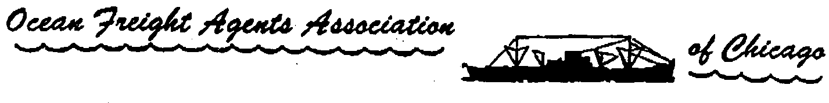

Ocean Freight Directory Advertiser Information
Deadline for Advertisements is February 22, 2019

The Ocean Freight Directory is a 1-color booklet and has a finished page size of 5.5" x 8.5"

All advertising needs to be black and white art.
Ads must be submitted as digital finished files.
Ad design is available at an additional charge.
Please contact the OFA if you would like additional information on ad design.

DIGITAL FILE FORMAT:
Press ready PDF files are preferred. However, please note PDF files cannot be edited.

RESOLUTION:
Ads should be of high resolution which is 300 dpi.
Web photos and graphics are not acceptable.

AD PROOF:
A laser proof of the ad must be submitted.

If you have questions regarding file format, resolution, ad proof, or media, please contact Edward Burgos at 773-580-6919.

CONTRACT FOR ADVERTISEMENT IN THE OFA DIRECTORY

Date: Click here to enter a date.

The undersigned hereby agrees to purchase the below space in the OFA Directory:

☐ Full Page $200 ☐ Quarter Page $75
☐ Half Page $100 ☐ Business Card $50

Click here to Type E-Signature.
(Signature of advertiser)

Name of Advertiser: Click here to enter text.

Business Address: Click here to enter text.

City / ST / Zip: Click here to enter text.

Phone: Click here to enter text.

Not subject to cancellation. Submitted by: Click here to enter text.
^{Please Print}
Checks payable to: Ocean Freight Agents Association

Email Application and artwork, and Mail Payment with Signed Contract to:

George Sebek C/O OFA
Mediterranean Shipping Company (USA), Inc.
8725 West Higgins Road Suite 400
Chicago, IL 60631, USA

