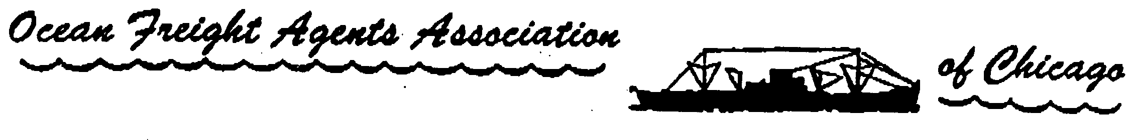

2018 Spring Traffic club of Chicago with the OFA Golf Outing!!!

DATE: JUNE 20, 2018

LOCATION: Bridges of Poplar Creek Country Club
1400 Poplar Creek Drive
Hoffman Estates, IL 60169
847.884.0219
http://www.bridgesofpoplarcreek.com/index.php

EVENT: OFA – Summer Golf Outing
-Registration starts at 11:30am SHOTGUN START BETWEEN 12-1PM
-Dinner is from 530pm to 800pm

COST: Register by Friday June 1, 2018 price is $125.00 per person after June 1, 2018 price is $150.00. Outing includes lunch, 2 drink tickets, golf and dinner

HOLE SPONSORS: $75.00 (your support is greatly appreciated)

RSVP: Send to JOHN.JANCZAK@MSC.COM and to
edward.burgos@hamburgsud.com

PRIZES: -Cash prizes for 1st, 2nd, 3rd lowest foursomes
-Longest Drive
-Longest Putt
-Closest to the pin
Both men and women
Additional On –Course events

EXCITING RAFFLE PRIZES!!

Please advise if you would like to sponsor a hole with your RSVP!

RESERVATION FORM

Name Company Dinner & golf

____________________________________________________________
Email reservations to: JOHN.JANCZAK@MSC.COM ; Edward.burgos@hamburgsud.com

Send Check Payment to:
Attn: George Sebek
Mediterranean Shipping Company
8725 West Higgins Rd., Suite 400
Rosemont, IL 60018

